**Assignment 4: Use of models in biology**

**Part I: Population dynamics**

Recall the model of ***density-independent*** population dynamics from the Week 11 Practical. For an organism with a current population size of *n*, the population size in the next year will be:

$$n^{'}=n\left(1+r\right)$$

where *r* is the intrinsic growth rate of the population. Recall that *r* is a function of the birth and death parameters of the population (*r* = *b* – *d* – *bd*, where *b* represents the average number of offspring each individual produces during the breeding phase of the life cycle, and *d* represents the proportion of individuals that die during the mortality phase).

**Question 1.** Consider a population of perennial plants that breed in the early spring and suffer high drought-related mortality late in the summer. Field monitoring experiments suggest that drought leads to a 50% decline in the population during the late summer (*d* = 0.5). Given this degree of mortality, use the model to calculate how many offspring each individual would, on average, have to produce during the breeding season to prevent the population from declining over time. In other words, calculate the minimum value of *b* that would be compatible with population growth. **[1 point]**

**Scoring:** Full credit for providing the correct answer and showing how the answer was obtained (*i.e.*, show your work).

For population to not decline over time, r ≥ 0. Thus:

r = *b* – *d* – *bd*

r ≥ 0

0 ≤ b – d – bd

0 ≤ b – 0.5 – 0.5b

0.5 ≤ b – 0.5b

1≤ 2b – b

b≥1

Therefore, each individual would have to produce 1 offspring each year to stabilise the population and produce more than 1 to increase the population.

Suppose that you are monitoring island endemic cricket population that has recently become threatened due to an invasive parasitoid wasp species that is attacking its members. From observations of birth and death rates, you estimate that the intrinsic growth rate of the cricket population to be $\hat{r}=-0.05$, which has a 95% confidence interval of:

95% C.I. for *r* = [-0.01, -0.1]

Since the entire confidence interval for your estimate of *r* is negative, your data imply that the population will decline over time.

**Question 2.** The current size of the cricket population is 5,000 individuals. Assume that the current conditions of parasitism do not change and, thus, *r* remains constant over time. Use your point estimate for *r* ($\hat{r}=-0.05$) and the model presented above to predict the amount of time it will take for the population size to decline below 50 individuals, which is the threshold for a “critically endangered” classification. Show how you arrived at your conclusion. **[1 point]**

**Scoring:** Full credit for providing the correct answer and showing how the answer was obtained (*i.e.*, submit the R code and relevant simulation output to justify the answer OR present a detailed mathematical solution to the question).

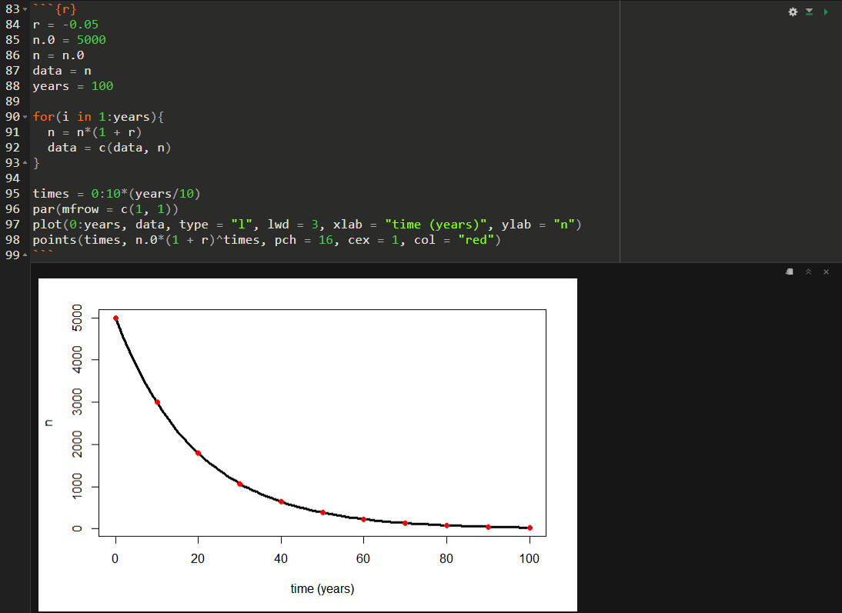

50 = 5000*(1 - 0.05)^t

t = 89.7

Therefore, it'll take 90 years for the species to be classified as critically endangered

**Question 3.** There is uncertainty around your estimate of *r*. Suppose that the true value of *r* is within the 95% confidence interval presented above. Use the model to calculate a best-case scenario and worst-case scenario for the amount of time it will take for the cricket population to become critically endangered. Show how you arrived at your conclusions. **[1 point]**

**Scoring:** Full credit for providing the correct answer and showing how the answer was obtained (*i.e.*, submit the R code and relevant simulation output to justify the answer OR present a detailed mathematical solution to the question).

**Part II: Evolutionary dynamics**

Recall the haploid model of evolution by natural selection from the Week 12 Prac. For a gene with two alleles (an *A* allele with frequency *p* and fitness *wA*, and an *a* allele with frequency *q* = 1 – *p* and fitness *wa*), the allele frequency in the next generation will be:

$$p^{'}=\frac{pw_{A}}{pw_{A}+\left(1-p\right)w_{a}}$$

**Question 4.** Imagine that you work in a lab that has recently carried out an evolution experiment in which there is a rapid increase in the frequency of an allele that they believe is beneficial in their study system (the study system is a microbial population of haploid individuals). Over a span of 25 generations, the allele has increased from an initial frequency of 0.05 to a final frequency of 0.95. Members of the lab wish to estimate the fitness advantage of individuals with the beneficial allele relative to the fitness of individuals without the allele (*i.e.*, they wish to estimate *wA*/*wa*, where *wA* is the fitness of individuals with the beneficial allele and *wa* is the fitness of individuals with the alternative allele). Use the allele frequency data and the haploid model to estimate the fitness advantage of individuals with the beneficial allele. **[1 point]**

**Scoring:** Full credit for providing the correct answer and showing how the answer was obtained (e.g., submit the R code and relevant simulation output to justify the answer OR present a detailed mathematical solution to the question).

$$25=\frac{\log\left(\frac{0.95\left(1-0.05\right)}{0.05\left(1-0.95\right)}\right)}{\log\left(1+s\right)}$$

$$s≈0.27$$

**Question 5.** Now consider a population in which the fitness advantage of the beneficial allele is 50% (*i.e.*, *wA*/*wa* = 1.5). Suppose the beneficial allele starts out as a single copy within a population of 100,000 individuals (its initially frequency would, therefore, be 10-5). Assuming that the advantage of the allele remains constant over time, how many generations will it take for it to reach a frequency of 0.5? How long would it take to reach a frequency of 0.99? **[1 point]**

**Scoring:** Full credit for providing the correct answer and showing how the answer was obtained (e.g., submit the R code and relevant simulation output to justify the answer OR present a detailed mathematical solution to the question).



It takes 272 generations for it to reach a frequency of 0.5 and 408 generations to reach a frequency of 0.99.